Quantum Linear Regression / Quantum Least‑Squares Regression

1. Problem
Given a dataset consisting of input–output pairs ( (x_i, y_i) ), the goal of linear regression is to find a weight vector ( w ) such that:
[ X w y ]
where ( X ) is the data matrix and ( y ) is the target vector. Classically, this is solved by minimizing the least‑squares error:
[ _w |Xw - y|^2 ]
Quantum Linear Regression aims to solve this problem using quantum algorithms, particularly quantum linear system solvers.

2. Intuition
Classical linear regression requires computing a matrix inverse:
[ w = (X^T X)^{-1} X^T y ]
This inversion dominates the computational cost for large datasets. Quantum algorithms such as HHL (Harrow–Hassidim–Lloyd) can solve linear systems exponentially faster under certain conditions by encoding matrices and vectors as quantum states.
The quantum algorithm outputs the regression coefficients ( w ) as a quantum state.
3. Circuit Structure
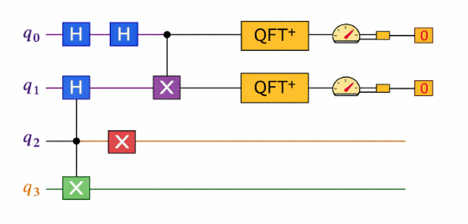
Quantum Linear Regression circuits are based on Quantum Phase Estimation (QPE) and controlled rotations, similar to HHL.
Registers: - Data register: encodes the vector ( |X^T y) - Eigenvalue register: stores eigenvalues of ( X^T X ) - Ancilla qubit: used for controlled rotations
High‑level flow: 1. Encode data into quantum states 2. Apply QPE on ( X^T X ) 3. Perform controlled rotations to invert eigenvalues 4. Uncompute QPE 5. Measure or post‑process the output state

4. Simple Math Involved
- Classical normal equation: [ (X^T X) w = X^T y ]
- Quantum formulation: [ (X^T X) |w= |X^T y ]
- Using spectral decomposition: [ X^T X = _i _i |u_iu_i| ]
The quantum algorithm inverts eigenvalues using controlled rotations: [ |u_i |u_i ]

5. Python Code (Qiskit Implementation – HHL‑Based Example)
import numpy as np
from qiskit import Aer
from qiskit.utils import QuantumInstance
from qiskit.algorithms.linear_solvers.hhl import HHL
from qiskit.algorithms.linear_solvers import LinearSystemInput
A = np.array([[1, 1],
[1, 2]])
b = np.array([1, 0])
input_data = LinearSystemInput(matrix=A, vector=b)
backend = Aer.get_backend('aer_simulator_statevector')
quantum_instance = QuantumInstance(backend)
hhl = HHL(quantum_instance=quantum_instance)
result = hhl.solve(input_data)
print("Quantum state |w>:", result.state)

6. Where the Algorithm Is Useful
- Large, sparse linear regression problems
- High‑dimensional data where matrix inversion is expensive
- Quantum machine learning pipelines
- Scientific computing and finance

7. Limitations
- Requires fault‑tolerant quantum hardware
- Outputs a quantum state, not classical coefficients
- Data loading (QRAM) is expensive
- Speedup only holds for sparse, well‑conditioned matrices

8. Comparison with Classical Linear Regression
- Computation: Classical regression explicitly inverts matrices; quantum regression uses a quantum linear system solver (HHL).
- Complexity: Classical methods scale polynomially with data size; quantum methods offer exponential speedups under ideal sparsity and conditioning assumptions.
- Data representation: Classical algorithms use explicit vectors and matrices; quantum algorithms encode data into quantum states.
- Output form: Classical regression returns numerical coefficients; quantum regression outputs a quantum state (|wangle).
- Practicality today: Classical regression is widely used in practice; quantum regression remains largely research‑oriented.

9. One‑Sentence Summary
Quantum Linear Regression solves least‑squares problems by encoding the normal equations into a quantum linear system and solving them using phase estimation and controlled rotations.

